|  |
| --- |
| 420-F20 |
| Networks |
| Assignment 2 |

|  |
| --- |
| St. Jean, Austin  5-11-2021 |

**Description of network**

In this diagram I made a network to connect all the devices within a school including, 2 printers, 33 individual computers, 8 switches and 1 router. This school has 4 classrooms, a library, a shared room, and a teachers lounge which all need to be set up and configured to a network. In a network, the router is the central hub for all the individual devices. Every device must be connected to the router in someway if its directly or through a switch. In my diagram each device is connected to the router through a switch. Each switch has a certain number of ports where you can connect a wire and where the other end of the wire connects to your device (i.e. printer or computer). The router has it’s ports and that’s how the switches get connected. In this diagram the router is located in the teachers lounge. The problem we must solve is how to set up a peer to peer network within the schools rooms and connect each of its printers and computers with switches and one router. We want to find to easiest, most efficient, and effective way to set up this network with the least amount of wiring as possible.

To start, the router is connected to the teacher’s lounge switch to connect its printer and 4 computers. It then branches out to both library switches and the shared room’s switch. The shared room’s switch connects its printer and single computer. This switch then connects to classroom 2’s switch. The reason we have one switch connected to another switch is because we don’t want hundreds of wires running back to the router. This is messy and very inefficient because there would be so many wires and you would also run out of ports on the router. Therefore our connection continues to classroom 2’s switch from the shared room switch to connect its 6 computers. We then continue our connection to classroom 1’s switch which is 1 of 2 switches farthest switch from the router. This switch connects our last 4 computers on the first half of the school. Going back to teachers lounge switch, it connects to the first library switch. This switch connects the majority of the devices in the library excluding 3 computers. The library is the only room in the school with 2 switches, this is because it has the most devices and we don’t want to overload the network. Therefore both library switches connect to the shared room and the second library switch connects to classroom 4. From there this switch connect classroom 4’s 4 computers and continues the connection to our final room, classroom 3, which is the second farthest switch from the router. Classroom 3’s switch connects its 3 computers and finishes our network.

**Legend**

-Blue-single wires

- Red-2 wires

- Orange-3 wires

- Green-Switch wires

Library

Classroom 2

Classroom 1

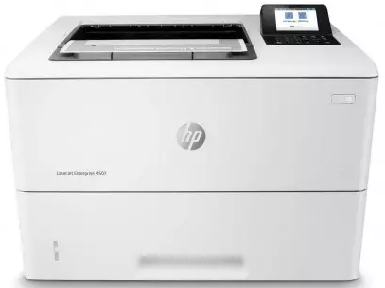

Shared room

Classroom 3

Teachers lounge.

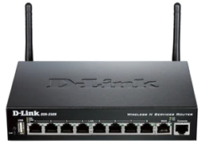

Classroom 4

Library

**Devices in diagram**

* Teachers lounge
* 1 router, 4 ports
* Library
* 2 switches
* 1st switch, 10 ports
* 2nd switch, 5 ports
* Shared room
* 1 switch, 4 ports
* Classroom 2
* 1 switch, 8 ports
* Classroom 1
* 1 switch, 6 ports
* Classroom 4
* 1 switch, 6 ports
* Classroom 3
* 1 switch, 4 ports